CS 255 System Design Document Template

This template lays out all the different sections that you need to complete for Project Two. Each section has guidance to prompt your thinking. You will need to continually reference the interview transcript as you work to make sure that you are addressing your client’s needs. There is no required length for the final document. Instead the goal is to complete each section based on what your client’s needs are. Remove this note when you are finished, and replace all bracketed text with the relevant information.

UML Diagrams

UML Use Case Diagram
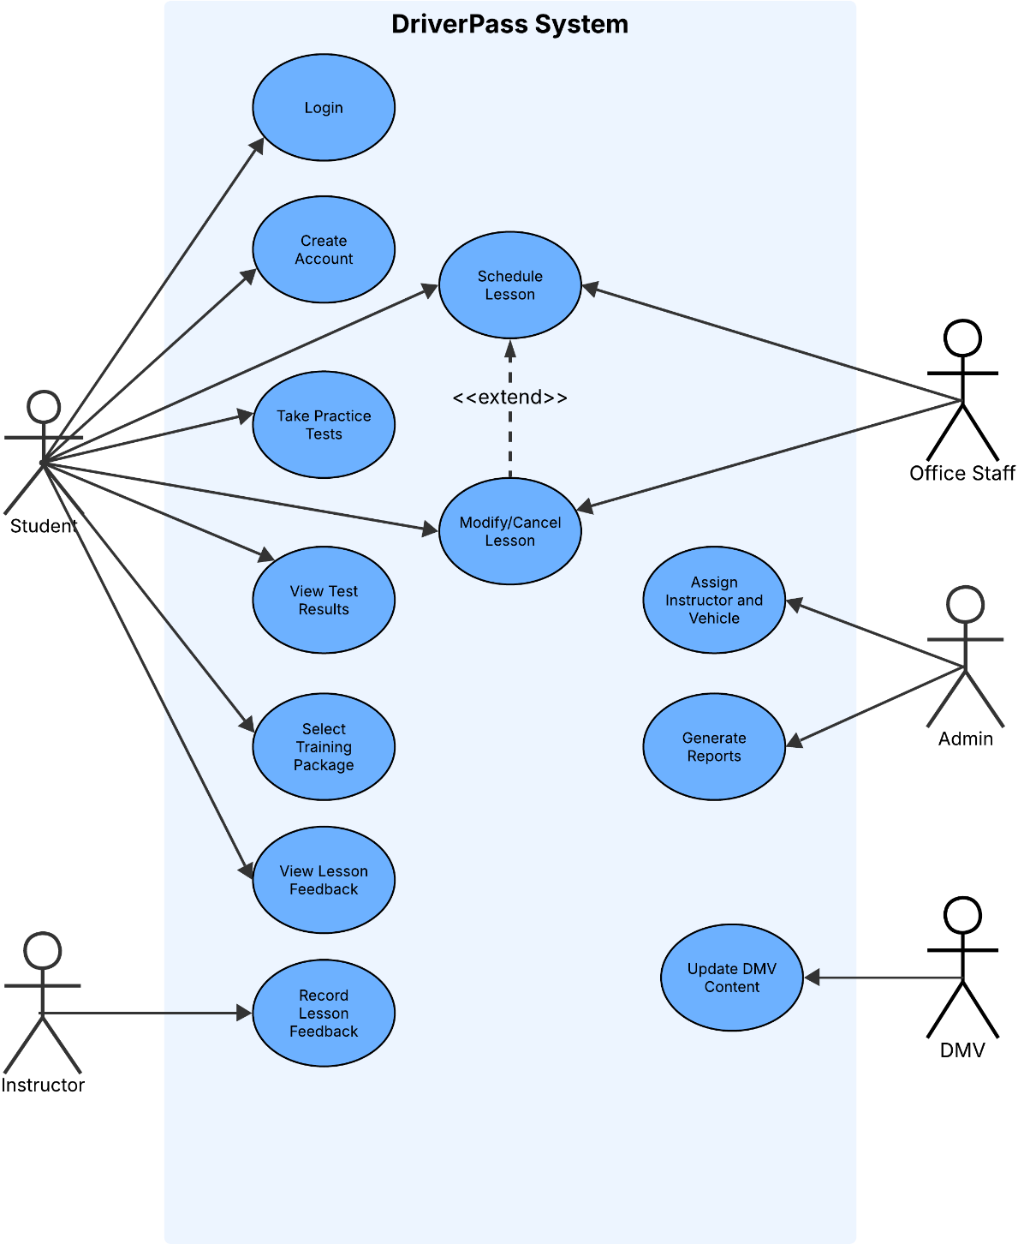

UML Activity Diagrams

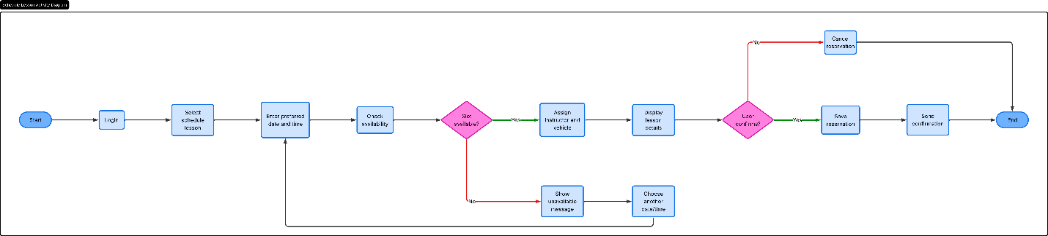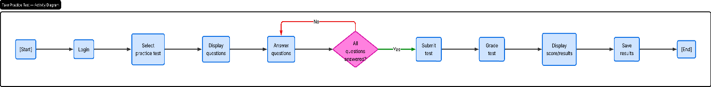UML Sequence Diagram
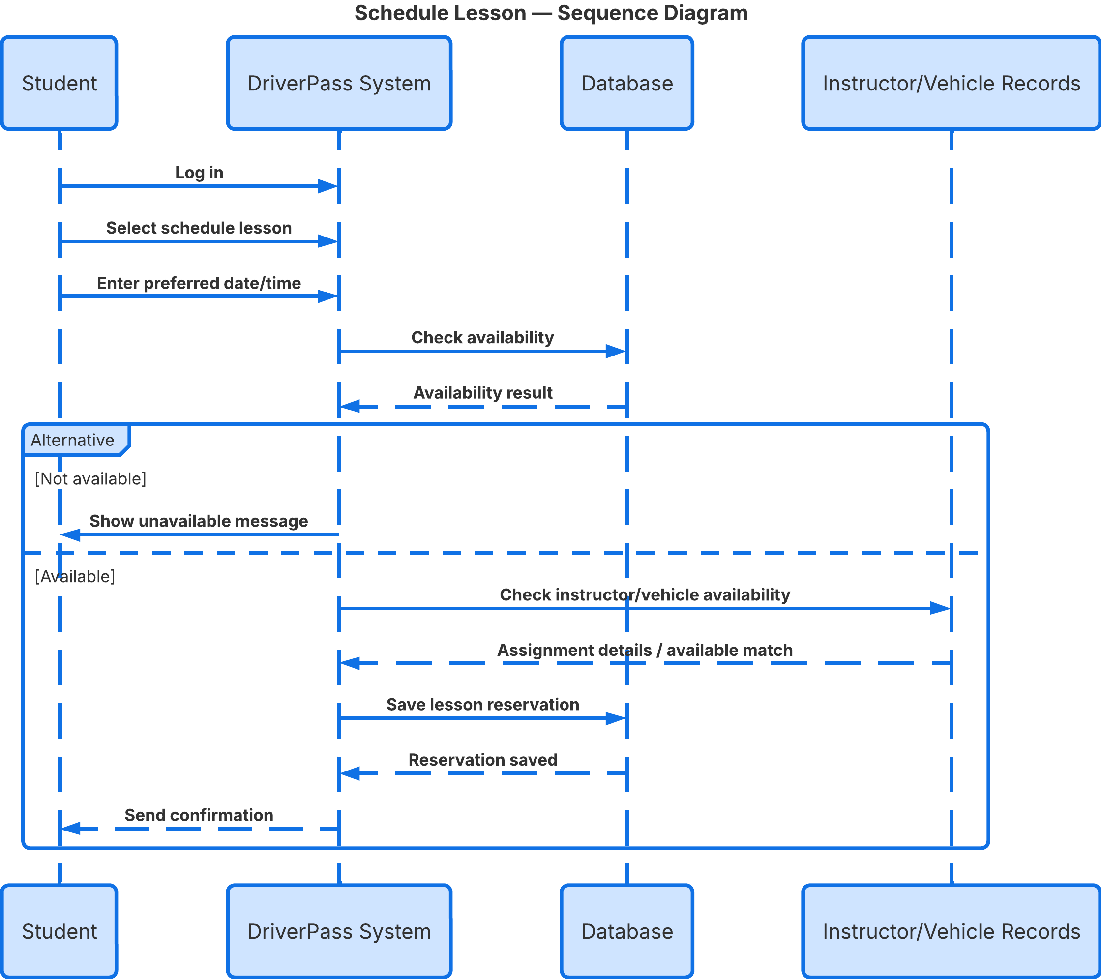

UML Class Diagram
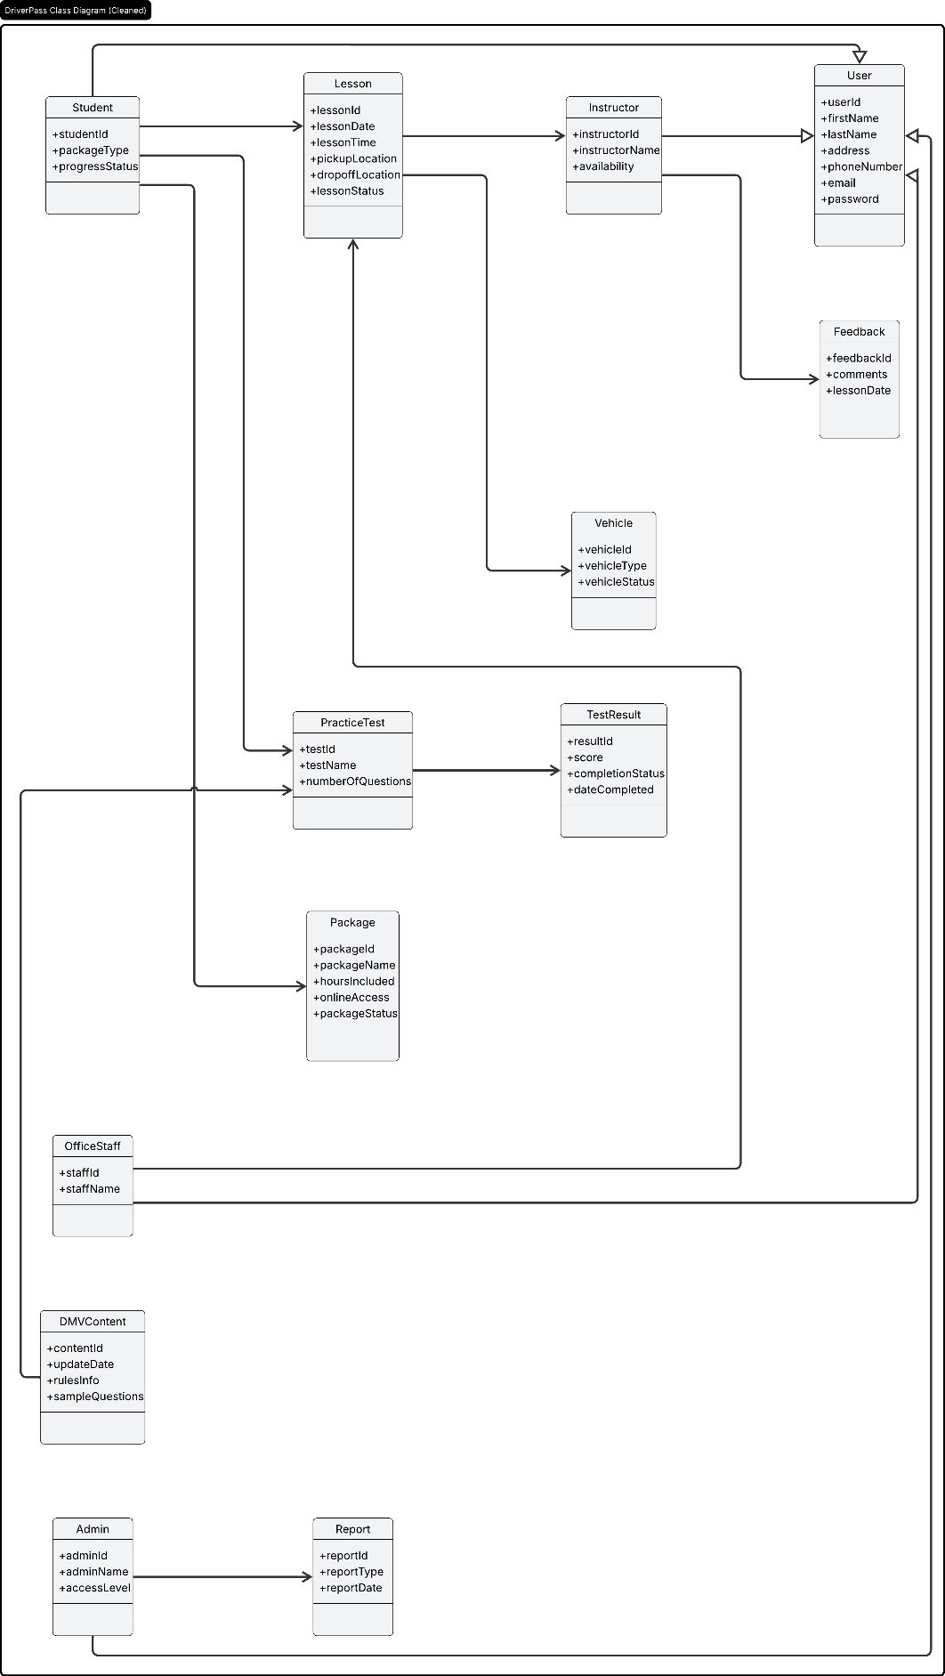

Technical Requirements
The DriverPass system will require a web-based platform that can be accessed through standard web browsers on desktops, laptops, tablets, and smartphones. This supports the client’s need for users to access the system online from different devices, including mobile devices. The system should support common operating systems such as Windows, macOS, Android, and iOS so that students, instructors, office staff, and administrators can all use the platform without compatibility problems.
The system will require secure server hardware or a cloud-hosted server environment to run the application and store system data. A cloud-based setup would be the best option because DriverPass said they want the system to run over the web and prefer not to manage backup and security on their own. The system will also require staff workstations for office employees and administrators, along with reliable internet access for all users.
The software requirements include a database management system to store user accounts, lesson reservations, instructor and vehicle assignments, package information, practice test results, lesson feedback, DMV content updates, and reports. The system will also require secure login software, password reset capability, and role-based access controls so different types of users only have access to the information and functions they need. Since the system handles personal and payment information, it should also use encrypted data transmission to protect information sent between the user and the system.
The system should also support scheduling functions, reporting tools, and online testing features. This includes the ability to check lesson availability, assign instructors and vehicles, save reservations, store practice test scores, and generate management reports. In addition, the system needs the ability to receive updated DMV rules, policies, and sample questions so the training materials remain current.
The design tools used for this project include Lucidchart for creating the UML diagrams required in the system design document. The final system would also require a web application framework and database tools that support account management, scheduling, reporting, and online learning functions. Backup and recovery support should also be included so the system can recover important data if there is a failure or outage.

